Pandas Trends

1. Gender Demographics

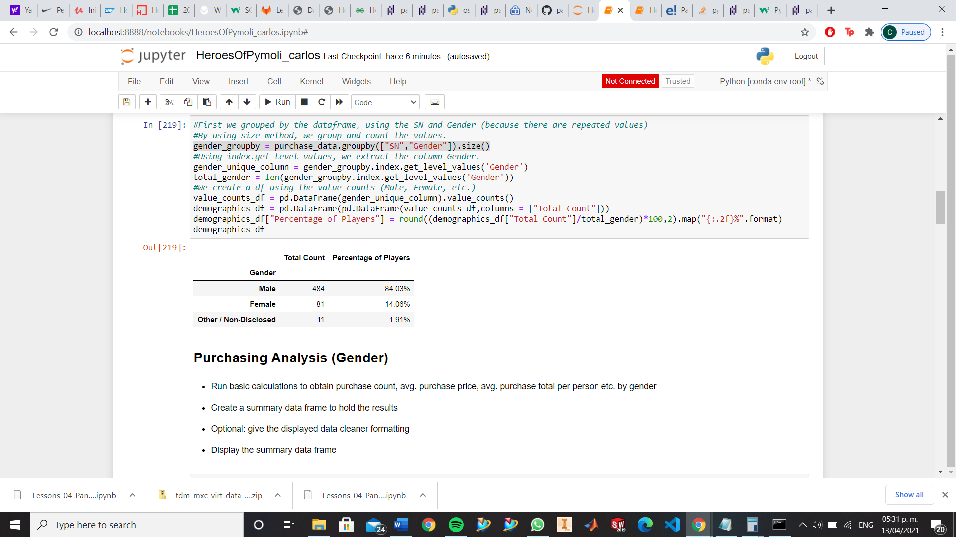

For the videogames industry, it is vital to identify the gender of their players, as they can focus (obviously, not leaving completely abandoned other groups) in certain specific trends and likes of the main population, to develop marketing and campaigns to maximize profits. It is even more important in games like HeroesOfPymoli, where it is free and their income comes from buying items.

2. Age Demographics

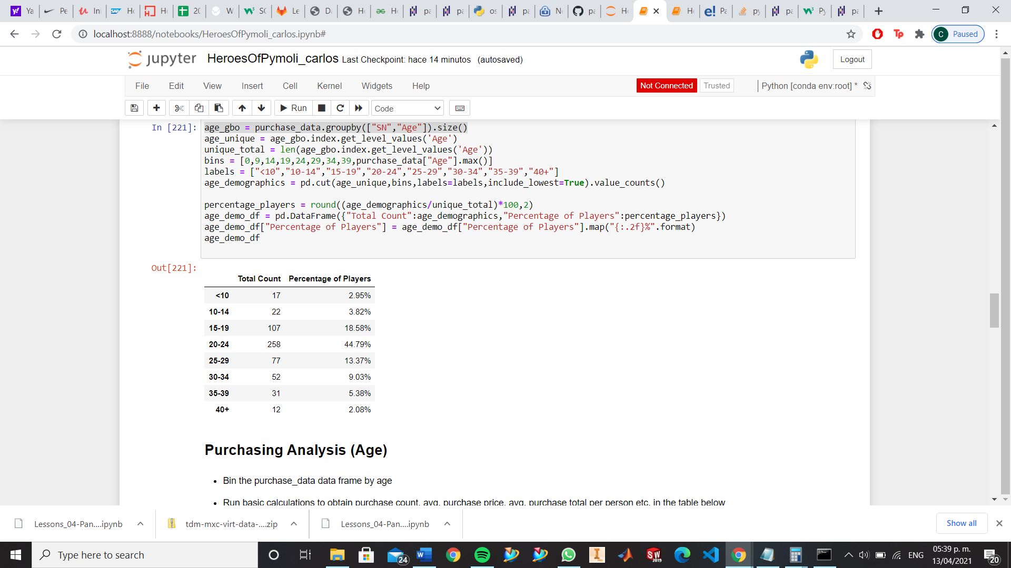

As important is the gender of our gamer population, but it is as important the age demographics of our population for us to build a correct “Profile” for our gamer. As we can see, the most of the population (almost 70%) is between 15-25 years. So, in the same way, we can look for the biggest trends in this population and prepare something for them.

3. Purchasing Analysis.

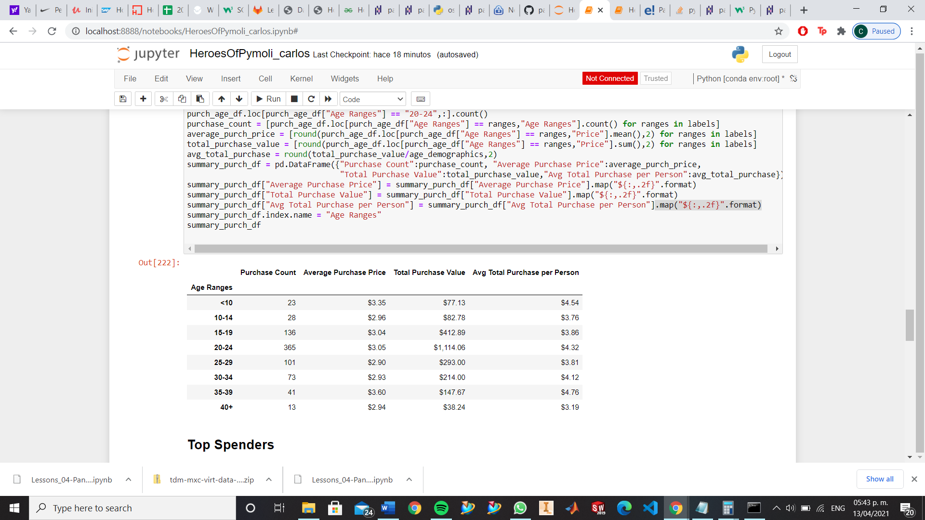

Related to the point before, the majority of our earnings come from the previously identified 15-25 years’ group. In this case, we strengthen and backup our idea to invest more on this group, for us to have more profit (but again, not leaving behind other groups).

4. Most popular and profitable items

Most popular items

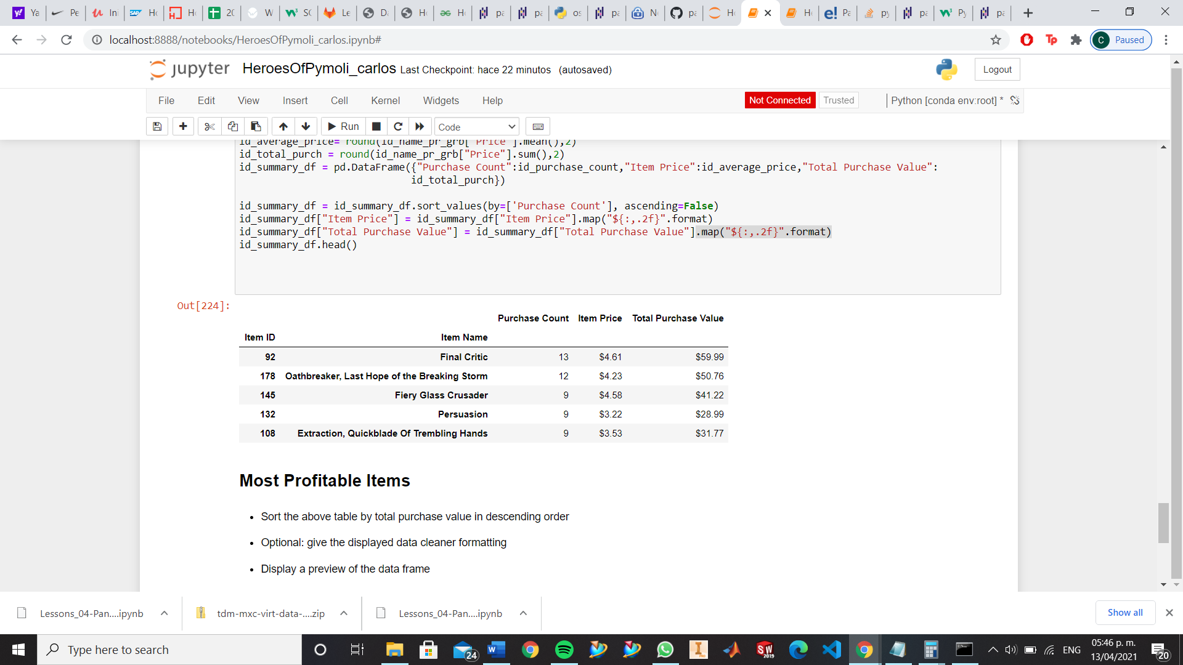

Most profitable items

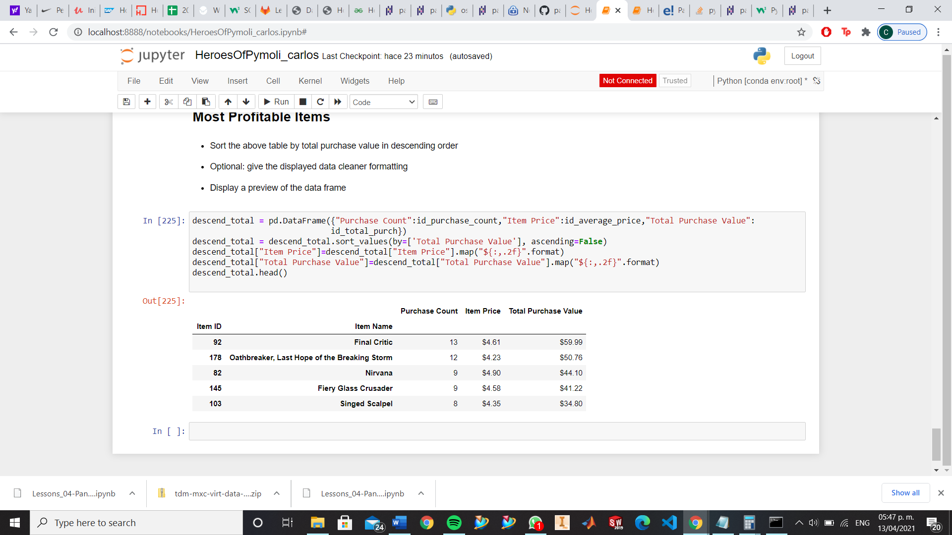

When analyzing the Most popular items and Most profitable items, we could see that 3 of the most popular items, are at the same time in the group of most profitable items. So, we could find the relation between those items and when releasing a new item, we could use the data of this analysis to create a “trending item” that will give us more income.